Congratulations to Chandana E Gowda, for securing 2nd Rank and Prakruthi R S for securing 7th Rank in 20th VTU Convocation.

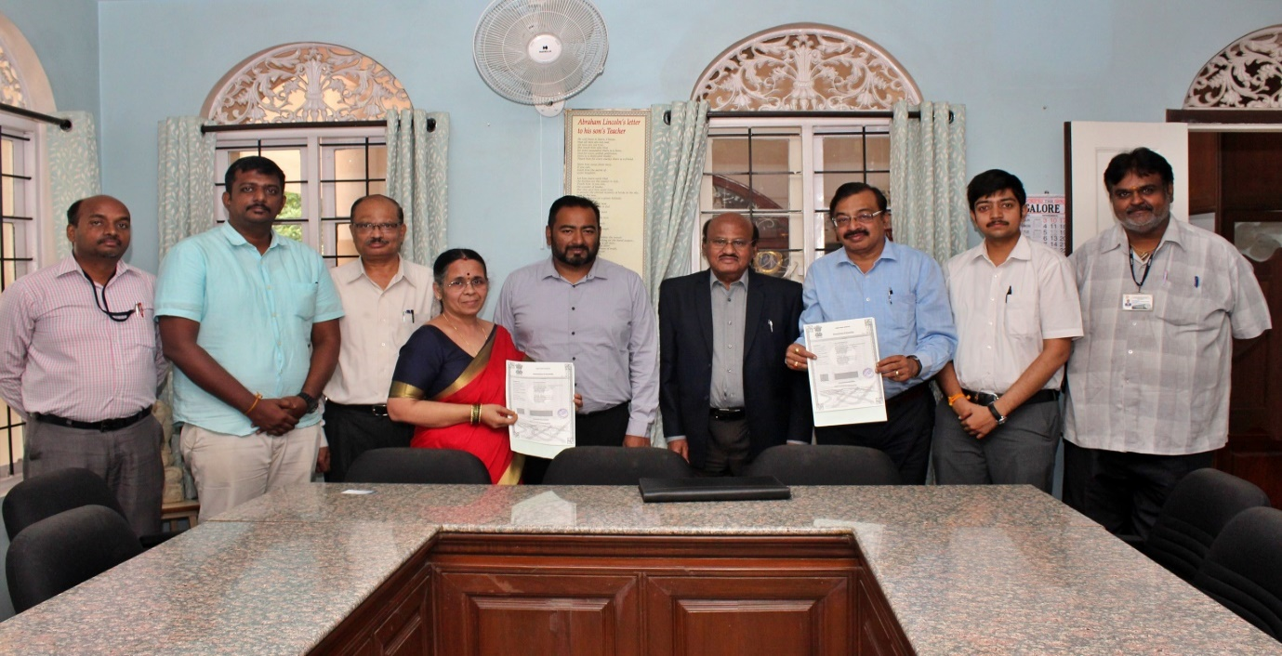
The Department of EEE Signed a Memorandum of Understanding (MoU) with Manobhu Technology Pvt Ltd, Bangalore on 18th November, 2019.

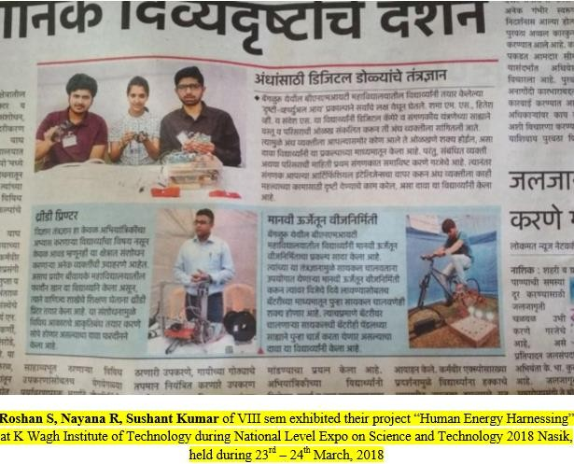

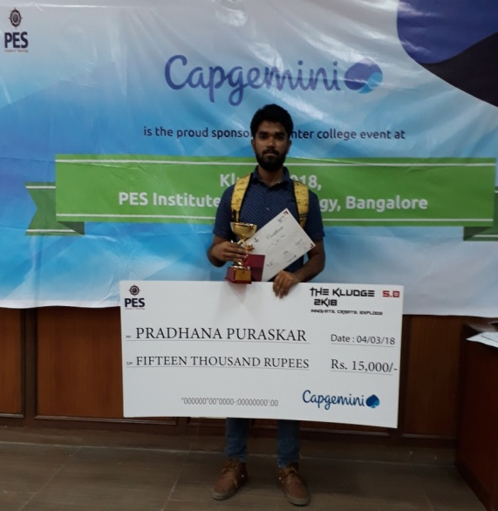
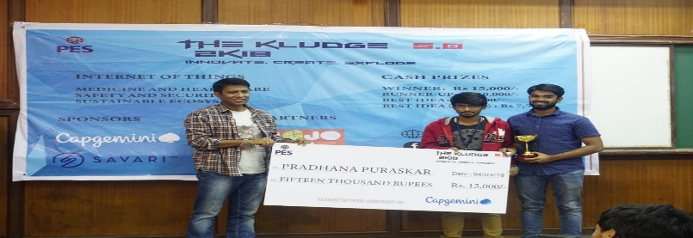
Syed Abrar of IV SEM EEE received a cash prize of Rs. 15,000 in THE KLUDGE 2018

